**ENTERPRISE INFORMATION SYSTEMS**

**Project 1**

**Planning, Design, and Implementation of ERP Systems**

**Submitted By:**

**Sheraz Ahmad**

**L13-4049**

**Section: BCS-8A**

**Index**

Corporate History, Experience, and Corporate Profile 3

Market Strategy and Strategic Direction 3

Product Offerings, Integration, and Scalability 6

Consulting Support 8

Availability of Training 10

Fit with Current Business Processes 11

Reporting Applications 12

User Friendliness 14

Cost 15

Ability to Integrate Finance and Accounting Module with other ERP Modules 16

References 17

# **Corporate History, Experience, and Corporate Profile**

NetSuite provides software and services to manage business finances, operations, and customer relations. Its software and services are tailored for small, medium-sized and large businesses with modules for ERP, CRM, PSA and e-commerce.

NetSuite was founded in 1998 by Evan Goldberg under the original name NetLedger, which offered web-hosted accounting software. NetSuite is widely seen as the first cloud computing software company, with the company’s 1999 founding pre-dating that of Salesforce.com by about a month.

NetSuite became a publicly traded company after its initial public offering (IPO) of 6.2 million shares on the New York Stock Exchange in December 2007.

Oracle Corporation acquired NetSuite for approximately US$9.3 billion in November 2016. The newly formed Oracle Netsuite business unit is managed by Executive Vice President Evan Goldberg as Oracle’s Cloud ERP for small and mid-sized enterprises.

One quarter of employees of NetSuite are based in its Philippine office. NetSuite has additional offices in Denver, Las Vegas, Austin, Chicago, Atlanta, New York City, Boston, Toronto, the United Kingdom, Spain, the Czech Republic, Hong Kong, Singapore, Australia, and Uruguay.

NetSuite is being used by over 20,000 customers across 203 countries. Their customer base includes industries from Financial, Manufacturing, Distribution and Wholesale, Advertising Media etc.

# **Market Strategy and Strategic Direction**

**Market Share**

According to Gartner data calculations, NetSuite is the fastest growing financial management system for the third in a row among the top financial management system vendors. It is industry leader in providing cloud based financial or ERP packages.

NetSuite managed to demonstrate huge gains on numerous metrics as per the last market share research by Gartner on FMSs. These include

* The growth rate of the FMS market share of NetSuite is 45 percent (globally). This is over 3 times the growth rate of its toughest competitor by market share.
* Among the top fifteen global FMS vendors, NetSuite stands to be the single cloud software provider.
* The FMS revenue growth of NetSuite globally was 40.3 percent. This is almost 4 times more than the growth of the provider’s closest competitor.[1]

**Market Strategy**

NetSuite is owned by Oracle. That is why it is promoted by Oracle as a part of its products and services. Apart from digital marketing, Oracle holds several conferences and webinars through out the year which present solutions to general problems of e-Business.

Oracle has signed more than 25,000 Cloud ERP customers including nearly 7,000 for Oracle ERP Cloud and 18,000 for NetSuite. Each quarter Oracle is migrating at least 200 customers of its on-premise ERP systems like E-Business Suite to the Cloud.[2, p. 10]

**Future Market Strategy**

NetSuite is used by several thousand companies to manage their accounting requirements, expense management, financial closing, auditable revenue management and real-time view of important data related to the financial performance of the company. The module can be seamlessly integrated into the other NetSuite software such as inventory, e-commerce functions, order management, and CRM.

**Other Strengths**

NetSuite ERP describes as a scalable, holistic cloud ERP solution aimed at high growth for both large and mid-sized business enterprises. It is used for automating front and back-end office operations including financial management, order management, revenue management, fixed assets, inventory management, and billing. Everyone in the organization including the top management and the clerical staff gets a customized view of all the important performance indicators as well as reports.

The inherent ERP integration in NetSuite offers an extensive 360-degree view of user data and communications. This includes a look at financial transactions. As compared to the CRM-only software packages, NetSuite provides sales staff visibility to orders, quotes, invoices, credit limits as well as outstanding receivables.[1]

# **Product Offerings, Integration, and Scalability**

**Overall ERP Product Line**[3]

Some of the main products of NetSuite are:

**1 - Enterprise Resource Planning (ERP)**

NetSuite Enterprise Resource Planning (ERP) offers a modern, scalable solution to run all of your key back-office operations and financial business processes in the cloud.

**2 - Global Business Management (OneWorld)**

NetSuite OneWorld delivers an integrated and unified platform that seamlessly handles multiple currencies, taxation rules and reporting requirements across business’ multinational and multi-subsidiary operations.

**3 - Customer Relationship Management (CRM)**

NetSuite CRM+ delivers true customer lifecycle management, from marketing and opportunity management, to order management, customer upsell, cross-sell, renewal and customer service.

**4 - Human Capital Management (SuitePeople)**

NetSuite SuitePeople is a Human Resources (HR) offering natively built on the NetSuite unified cloud suite. SuitePeople offers powerful functionality for organizations to manage their core HR and workforce management processes, and an exceptional employee experience to complete most everyday tasks.

**5 - NetSuite Professional Services Automation (PSA)**

NetSuite provides complete web-based PSA including resource management, project accounting and timesheet and expense management, all tightly integrated with NetSuite's SaaS accounting, CRM and ecommerce capabilities.

**6 - OpenAir**

OpenAir supports your entire services organization with real-time visibility and anytime, anywhere access to the tools and information you need. Decrease non-billable bench time, improve project management, automate your billing and invoicing process and optimize revenue and profitability reporting.

**7 - Omnichannel Commerce**

Unify ecommerce, marketing and POS with your back-office systems to deliver consistent and personalized brand experiences across all channels.

**8 - SuiteSuccess**

SuiteSuccess is a transformative customer engagement methodology that engineers lifelong customer success through leading practices, years of experience and deep industry domain knowledge in cloud ERP implementation.

**Module Integration Strategy**

SuiteTalk web services integration makes it easy for customers and developers to integrate NetSuite with a variety of applications including existing on-premise investments and third-party cloud applications, and to build website-to-NetSuite integrations or create lightweight custom mobile applications.

Also, there is one more product from NetSuite which helps in integration with other modules. Jitterbit helps achieve more from NetSuite Integration by quickly connecting business data with any other in-house or cloud-based systems.

Apart from services provided by NetSuite itself, there are number of third-party service providers who build custom solutions according to your needs.

**Web-based Application Strategy**

NetSuite provides web-interface for all your needs. NetSuite’s web-based application includes web CRM solutions, accounting / ERP solutions, eCommerce and web store as well.

**New Offerings**

Since NetSuite is a cloud-based service, it makes it very easier to scale and provide as much service as required. New products are added regularly and integrated into the cloud system. And those products are readily available to each and every customer on demand.

# **Consulting Support**

**Support for Configuration of Application Modules**

Your success is a top priority at NetSuite and we ensure that our customers receive the maximum return on their investment. That’s why every customer gets basic support.

But as your business grows, you may need additional support. NetSuite offers a full range of support offerings, from Basic to Premium, to Advanced Customer Support. Each option provides specific service levels and capabilities, from online case submissions to 24/7 phone support, to managed services that help minimize the gap between your optimal solution and your actual solution.

All NetSuite subscriptions include Basic Support with Premium Support available to meet additional support requirements. Count on us to be there to support your business.

**Technical Support for System Implementation**

Technical support for System Implementation is available at all levels. From just advising to platform level in-person support. Advanced Customer Support (ACS) allows you to react to all of these changes and maximize the value of your Oracle NetSuite solution on a continuous basis. Oracle NetSuite has created a single offering to meet all support and ongoing sustainment and optimization needs across all products and all markets.

ACS offers five levels of support: Advise, Monitor, Optimize, Architect and Platform. As you move up levels, we increase our level of support.

**Cost of Consulting Support**

Consulting support is available free of cost over the telephone 24/7. Apart from this, all subscriptions are entitled to a free basic level support. As you move up, more advanced level of support unlocks.

**Availability of Consulting Support**

Here is the support model for NetSuite:

|  |  |  |
| --- | --- | --- |
|  | **BASIC** | **PREMIUM** |
| Coverage Hours | 24x7 access for Severity 1  Business hours access for Severity 2 (Online only) | 24x7 access for Severity 1 & 2  Business hours access for Severity 3 & 4 |
| Eligible to Join the NetSuite User Community | Yes | Yes |
| Access to SuiteAnswers Technical Support Portal | Yes | Yes |
| Online Case Submission | Yes | Yes |
| Telephone Case Submission | For Severity 1/Critical only | Yes |
| 24x7 Critical Access | Yes | Yes |
| Authorized Support Contacts In Your Organization for Non-Critical Concerns | No | 4 |
| 8x5 Non-critical Access | No | Yes |
| 24x7 Non-critical Access | No | Yes |
| Commerce Response Services | No | Yes |

# **Availability of Training**

To fully unlock the benefits and maximize your investment, you need to empower your team members to understand, implement, and fully leverage the new system. You need expert training resources and support that are accessible, convenient and comprehensive—all of which you may not have in-house. You need to focus on keeping daily operations at optimal productivity, not spending time making sure everyone has the knowledge they need to maximize the new system.

NetSuite offers several courses for anyone to get proficient in using their services. Starting with NetSuite essentials.

This course if for people who

* Are responsible for the setup, configuration, and maintenance of the NetSuite Application for your company.
* Are responsible for implementing a NetSuite OneWorld account for subsidiaries or entities with local and consolidated reporting requirements

**Duration**: 5 days

**Price**: $4,000 USD

# **Fit with Current Business Processes**

Used by thousands of organizations worldwide, NetSuite's financial management solution expedites daily financial transactions, accelerates the financial close and ensures compliance. Our cloud-based single platform architecture ensures complete real-time visibility into the financial performance of the business from a consolidated level down to the individual transactions.

NetSuite financial management seamlessly integrates with all NetSuite order management, inventory, CRM and ecommerce functions to streamline critical business processes.

**Billing**

NetSuite’s billing management capabilities integrate your sales, finance and fulfillment teams – improving accuracy, eliminating billing errors, strengthening revenue recognition processes and driving fulfillment accuracy and efficiency.

**Revenue Recognition**

NetSuite’s revenue recognition management solution helps companies comply with accounting standards and report financial results in a timely manner.

**Financial Reporting**

From reporting and analytics, to insight and decision-making, gain a more complete picture of your business on-demand and in real-time.

Here’s a product demo:

[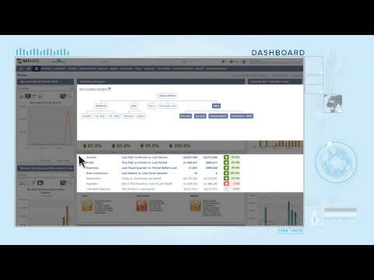](https://www.youtube.com/embed/ab1UUdDmsxw?feature=oembed)

# **Reporting Applications**

With NetSuite, your finance team gets more than automated and accurate financial statements. Your entire organization gains a modern financial reporting experience that delivers real-time financial analysis and modeling across every dimension of your business for detailed insights into corporate performance and improved business decision making.

**Features**

**On-demand, real-time insights your way:**

* See the big picture with dashboards and KPI’s tailored to your role.
* Use standard, out-of-the box reports, or easily customize to your business requirements.
* Securely access financial reports from anywhere using a web browser or mobile device.
* Financial reports are highly flexible and can be easily customized to see specific types of GL accounts, transaction fields or even custom field values as they are recorded on transactions.
* NetSuite’s easy-to-use Financial Report Builder tool allows you to craft the financial statements you need for your reporting requirements. This includes grouping financial data differently, for example by classification rather than account, or including additional data in the report such as budget details.
* Report layouts can also be tailored for a different presentation formats or formatted to highlight critical data.

**Flexible, Multi-Dimensional Reporting**

* Dynamic GL segments capture and store transactions for multidimensional reporting and single version of truth.
* NetSuite goes beyond financial metrics and tracks statistical and operational data to enable a comprehensive view of the business.
* Analyze information by any dimension in real-time.
* Diagnose financial issues on-the-fly and drill-down transactional details to quickly take action and drive business performance with informed decisions.

**Global Compliance**

* NetSuite financial reporting provides global support for both internationalization and localization
  + Multiple accounting books
  + Multiple Fiscal and Tax calendars
  + Localized tax calculations and reporting
  + Local format Income Statement and Balance Sheet
  + Audit and Compliance Reporting
* Generate accurate statements and reports that comply with accounting standard e.g. US GAAP and IFRS

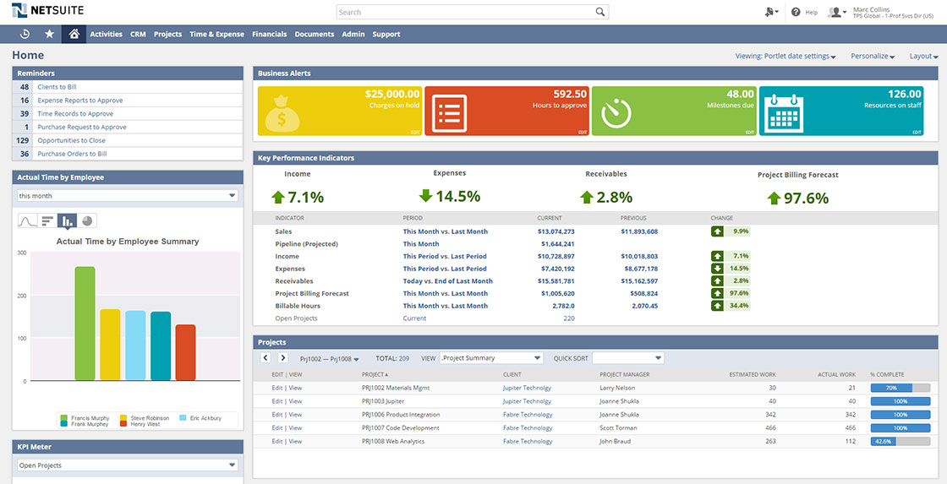

Analytics Screenshot

User Friendliness

NetSuite has a dedicated YouTube channel which contains all the basic tutorials. It shows in-depth method of each and every task required to do in NetSuite. Apart from this, several other videos on YouTube contain tutorials about NetSuite.

Apart from this, detailed documentation about NetSuite and any of its module can be found on our official website. The interface of the documentation website is very user-friendly. It contains all the documents in alphabetical order for the convenience of the user. There’s a search bar available as well. User can enter the search query and find the relative documentation.

The documentation is in pdf format. Everything is explained in great detail in these PDFs. It not only contains screenshot to help explain a task but it follows a very beginner step-by-step format.

Here is a sample from one of our documentation:

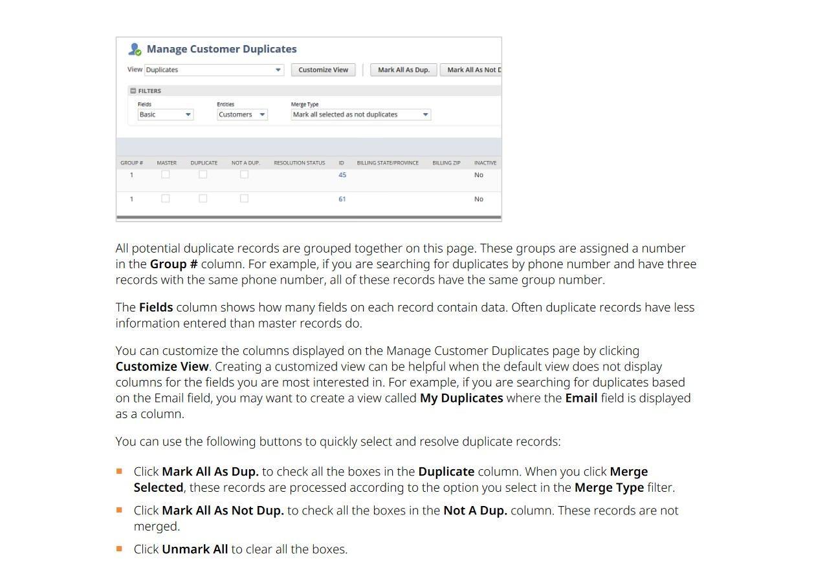

Documentation Sample

Cost

The Financial Management module offers users real-time access to live financial data and direct links between accounting and compliance management. Users can expect to get accelerated closings, accurate reporting and real-time data.

NetSuite’s price is tailored to each customer, predicated on a set of givens, including ERP configuration, required add-on modules, total user count and contract length. Its base license costs $999 per month with access costs of $99 per user, per month.

The NetSuite license operates as a subscription model and may be renewed annually or over longer intervals. Several pre-bundled vertical editions of NetSuite are also available, which can be useful in quickly identifying the package and modules that would satisfy a customer’s needs.

The training cost for Financial Management module is $1,600 and has a duration of 2 days.

Here are the things taught in this course:

* Manage customer relationships to ensure my company is paid the money owed for providing goods or services
* Manage vendor relationships to ensure my company reflects the debts owed for receiving goods or services
* Identify and use General Ledger functionality
* Set up and use Multiple Budgets so that I can plan my future income and expenditure
* Set up and use Expense Allocation so expenditures are automatically spread throughout my organization

Ability to Integrate Finance and Accounting Module with other ERP Modules

For this, NetSuite has a solution called, Two-tier ERP – it’s a business and technology strategy that enables organizations to keep their investment in existing ERP systems such as SAP or Oracle at the corporate level, while empowering subsidiaries and divisions to innovate with a second ERP system that gives them more agility and better total cost of ownership.

At NetSuite, we’ve helped multi-entity, multinational companies in a range of industries capitalize on the benefits of the two-tier ERP model. You can deploy NetSuite for ERP/financials, CRM, ecommerce, supply chain and more at your satellite operations, and synching with on-premise ERP at headquarters.

For such customers, the key to two-tier ERP is NetSuite OneWorld, the first and only on-demand system to deliver real-time global business management and financial consolidation, with local customization and full integration capabilities with SAP or Oracle. The real-world success of these NetSuite customers testifies that two-tier ERP is not some future-state vision – it’s a practical and proven solution that is driving quantifiable business benefits today.

References

[1] “The Cloud ERP Market - How NetSuite Stands Out from the Crowd,” *Amzur*, Oct. 11, 2018. https://amzur.com/blog/the-cloud-erp-market-how-netsuite-stands-out-from-the-crowd/ (accessed May 10, 2020).

[2] A. Pang, “Top 10 Cloud ERP Software Vendors, Market Size and Market Forecast 2019-2024,” *Apps Run The World*, Feb. 13, 2020. https://www.appsruntheworld.com/top-10-cloud-erp-software-vendors-market-size-and-market-forecast-2019-2024/ (accessed May 10, 2020).

[3] “Business Solutions, Business Software Solutions, SaaS Software – NetSuite.” https://www.netsuite.com/portal/products.shtml (accessed May 10, 2020).

[4] K. Craig, “NetSuite ERP Review,” *Better Buys*, May 18, 2018. https://www.betterbuys.com/erp/reviews/netsuite-erp/ (accessed May 10, 2020).

[5] “NetSuite Essentials.” https://www.netsuite.com/portal/services/training/suite-training/description-essentials.shtml (accessed May 10, 2020).

[6] “NetSuite: Financial Management.” https://www.netsuite.com/portal/services/training/suite-training/financial-management.shtml (accessed May 10, 2020).

[7] “wp-two-tier-erp-strategy-kit.pdf.” Accessed: May 10, 2020. [Online]. Available: https://www.netsuite.com/portal/pdf/wp-two-tier-erp-strategy-kit.pdf.